Data: 27/03/2026
Responsáveis pelas análises: Professores Marcos e Daniela

- Simulação V7 (Versão 7): parâmetros da configuração considerada:
  - epsilon_decay_types = ["fixed"]
  - reward_types = ["R1","R2","R3"]
  - gamma = 0.15
  - alpha = 0.75
  - epsilon_set = [0.01]
  - repeat = 5
  - episodes = 10000

Resultados descritivos
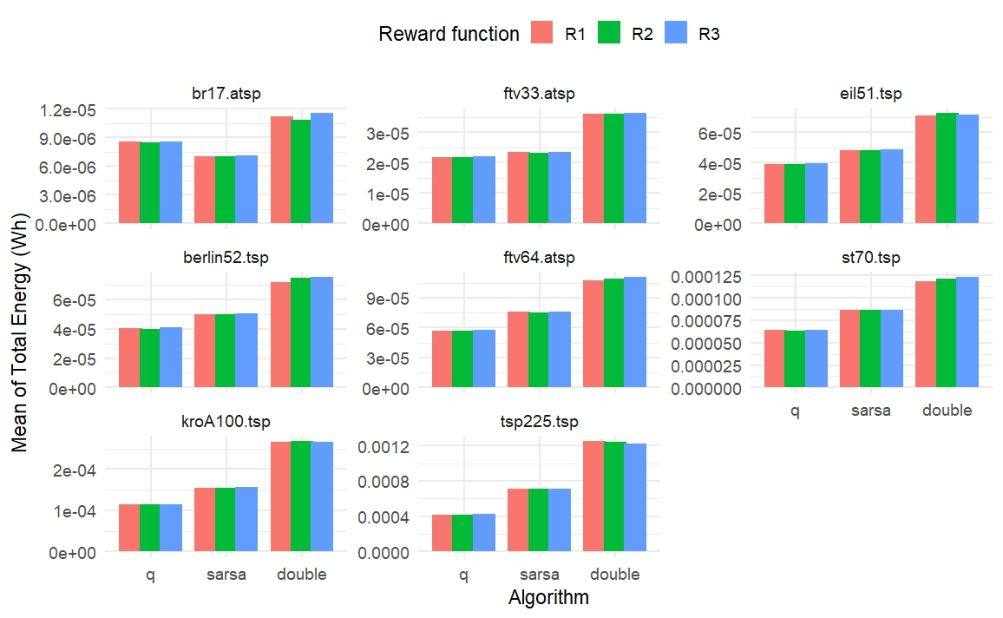
Figure 1: Mean Total Energy by Algorithm and Reward Function across Instances

Figure 1 shows that only for the br17.atsp instance did the SARSA algorithm exhibit the lowest mean energy consumption. For all other instances, Q-Learning consistently achieved the lowest mean energy consumption, regardless of the reward functions considered.

O resultado acima responde de forma descritiva as perguntas 1 e 2.
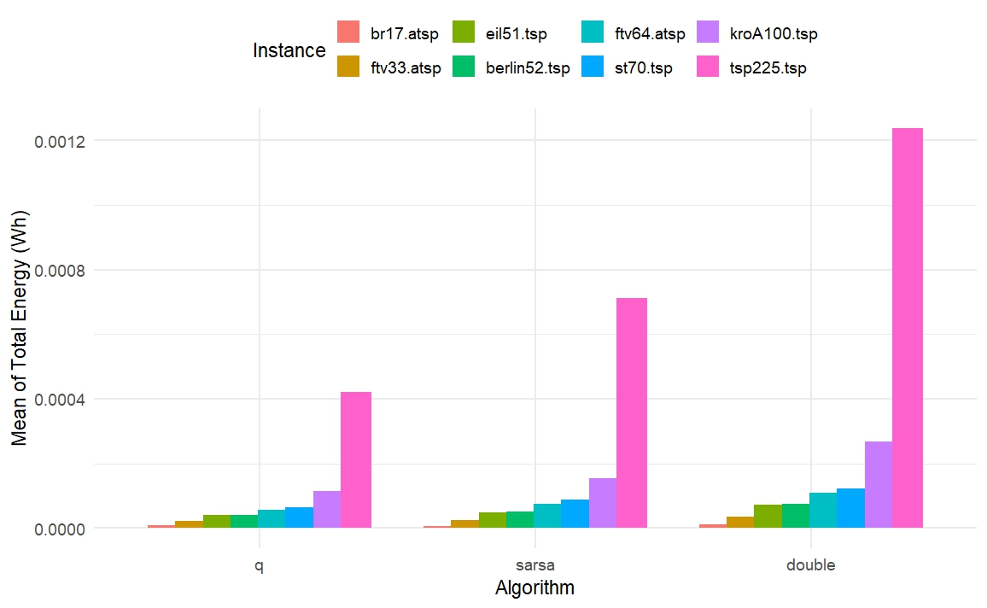
Figure 2: Mean Total Energy by Instance Size across Algorithms

As the instance size increases, the mean energy consumption rises for all algorithms, with the smallest impact observed for Q-Learning, followed by SARSA, and then Double Q-Learning.

O resultado acima responde de forma descritiva a pergunta 4.

Resultados inferenciais
- VD: Total_Energy_Wh
- Foi realizado um modelo fatorial 3x3 para cada instância, tendo como fatores Algoritmo e Funções de Recompensa e realizado o teste de comparações múltiplas de Scott-Knott.

Table 1: Factorial Analysis Results of Mean Total Energy for Algorithms and Reward Functions with Scott–Knott
Instance | Algorithm | Reward | Interaction | Scott–Knott (Lowest Energy)
br17.atsp | Yes | No | No | sarsa
ftv33.atsp | Yes | No | No | q
eil51.tsp | Yes | No | No | q
berlin52.tsp | Yes | No | No | q
ftv64.atsp | Yes | No | No | q
st70.tsp | Yes | No | No | q
kroA100.tsp | Yes | No | No | q
tsp225.tsp | Yes | No | No | q

Table 1 indicates that the algorithm factor is statistically significant for all instances, while neither the reward function nor the interaction between factors shows a significant effect on mean total energy. This suggests that differences in energy consumption are primarily driven by the choice of algorithm, regardless of the reward structure.

Specifically, for the br17.atsp instance, the Scott–Knott test identifies SARSA as the algorithm with the lowest mean energy consumption across all reward functions (R1, R2, and R3). In contrast, for all other instances, Q-Learning consistently achieves the lowest mean energy consumption, also independent of the reward function considered.

Overall, these results reinforce that Q-Learning is the most energy-efficient algorithm for larger instances, whereas SARSA only outperforms it in the smallest instance analyzed (br17.atsp), and that reward functions do not significantly influence performance in this context.

O resultado acima responde de forma inferencial as perguntas 1 e 2.

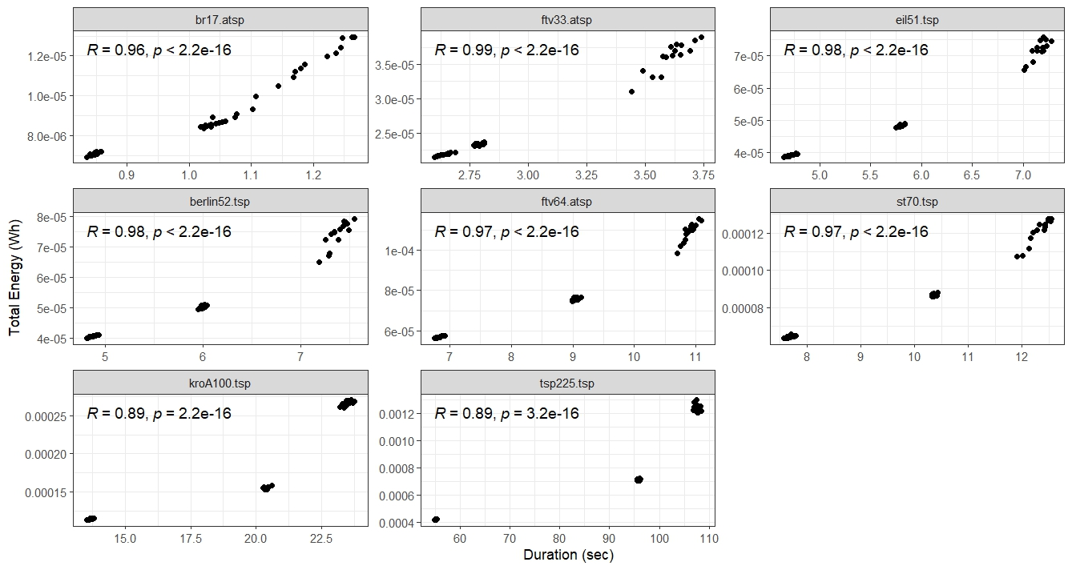
Figure 3: Duration versus Total Energy by Instance

Figure 3 shows a clear positive linear relationship between duration (in seconds) and total energy consumption across all instances. Within each panel, the correlation coefficient is displayed along with a p-value < 0.01, indicating that the Pearson correlation is statistically significant for all instances.

O resultado acima responde de forma inferencial a pergunta 5.

Em relação a questão 3, a saber:
“3) Como encontrar uma configuração de algoritmo x recompensa que garanta um bom resultado de rota sem alto custo de energia?”

Os resultados obtidos permitem concluir que o Q-Learning, na configuração específica avaliada, apresentou o melhor desempenho geral. Essa conclusão é sustentada pelo fato de que não foi observado efeito significativo das funções de recompensa em nenhuma das instâncias, indicando que a escolha do algoritmo é o principal fator que influencia a eficiência energética nesse contexto.

Lembrando que todos os resultados se referem unicamente à configuração considerada na simulação.

